Python Tetris

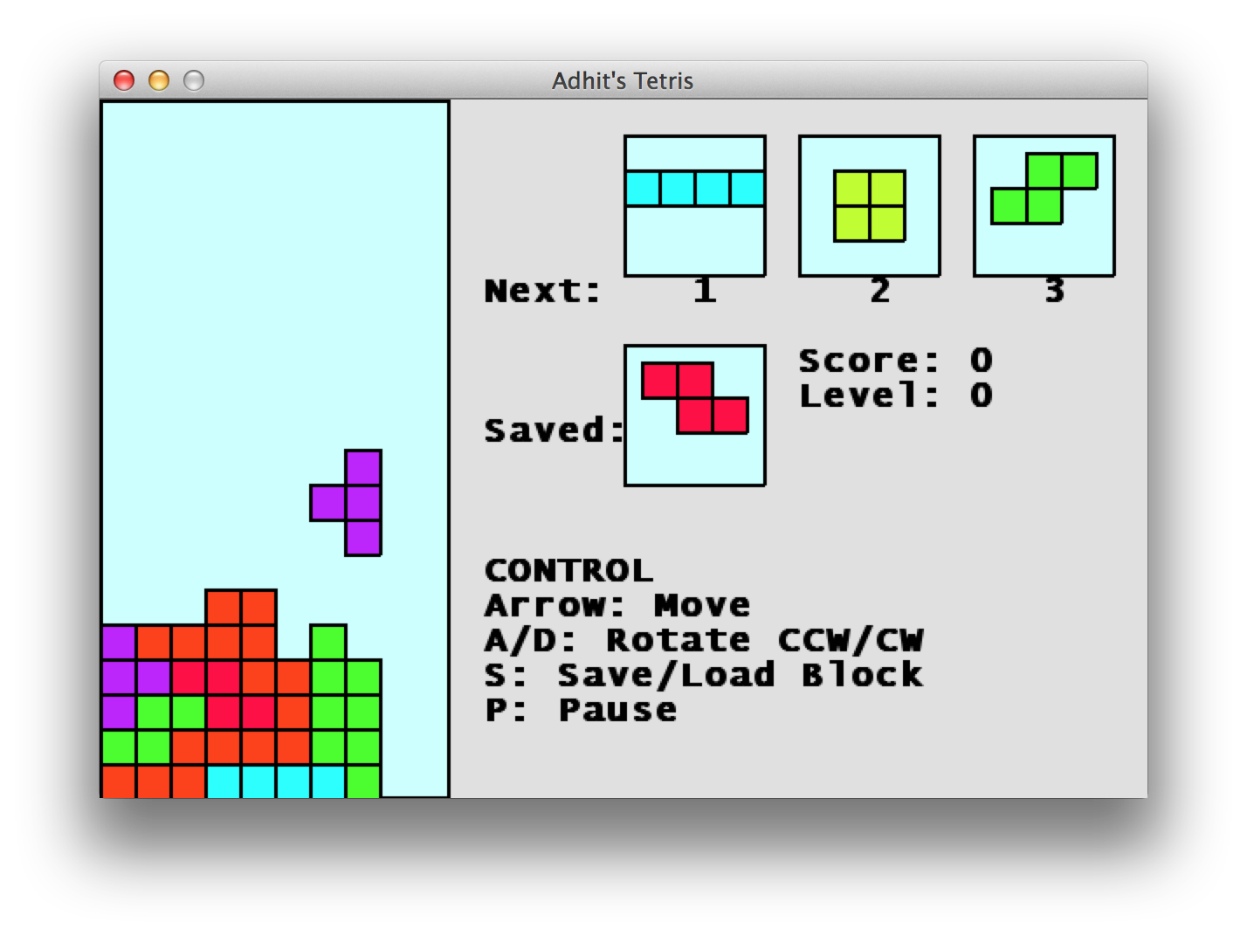

# Basic Assumptions

1. Tetris pieces are falling down one at a time. This tetris piece is controllable by the player.
2. The currently active tetris piece stops falling down when it hits the bottom of the board or another tetris piece. At this point, the position of that tetris piece is ‘settled’ and a new tetris piece will be falling down
3. A tetris piece contains of 4 blocks. There are 7 types of tetris piece

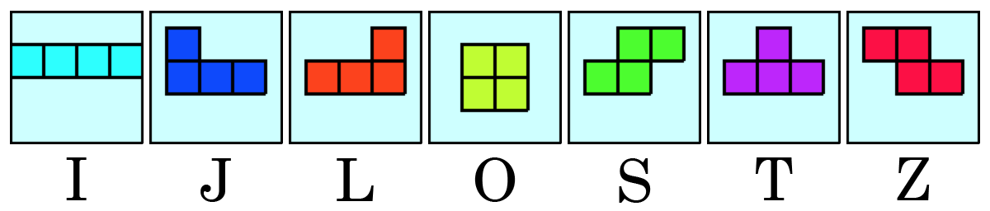

1. Tetris board is 10 blocks width and 20 blocks high
2. When the highest block of all pieces is located higher than 20 blocks, then the player lose
3. A player can do one of the 6 actions on the active tetris piece at one time: ‘move left’, ‘move right’, ‘move down’, ‘rotate ccw’, ‘or ‘rotate cw’. Player can’t move a piece through another block, the left, right, or bottom border.
4. When a horizontal line of 10 blocks is aligned, that line disappears, player gets point, and all blocks above that line goes down by one.

# PyGame

We are using PyGame library to make this game. Resources on getting started with PyGame can be found here:

* <http://pygame.org/wiki/tutorials>
* <http://www.learningpython.com/2006/03/12/creating-a-game-in-python-using-pygame-part-one/>

# Object Representation of The Game

This is not by all means intended to limit the fun and your creativity in designing your Python Tetris. Use this as a guideline to consider.

## TetrisGame

This is the main object that controls the gameplay. It should have the main loop of the game. Each iteration of the main loop does two things:

1. Reads and responds to events (both player-generated such keystrokes, and system generated such as quit event and ‘moving down’ tick event), and stores the changes to game data.
2. Draw on the screen corresponding to game data

It has a 10x20 2D list of Square(s) to keep track of the state of the game board.

## Piece

This represents a Tetris Piece. A Piece consists of four Square(s), which are represented as a list of four Square(s). This is the suggested ‘center’ for each type of Piece, to make rotating easier:

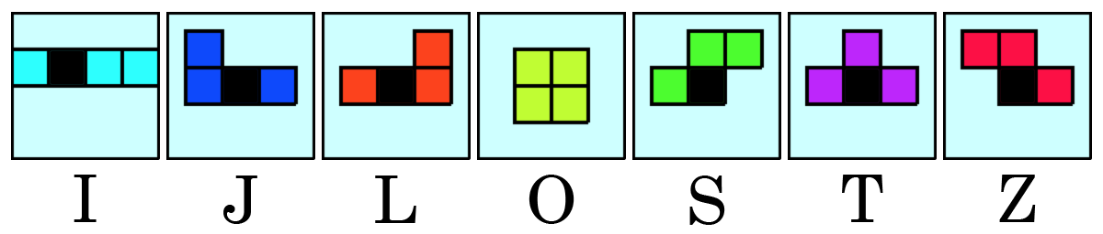

## Square

This represents a Square that occupy the game board and constructs a Piece.